PGE Schematic Geoprocessing Tools

October 2, 2013

The PGE Schematic Geoprocessing Tools were developed for PG&E as a set of custom geoprocessing tools to be used in various schematic workflows. The PGE Schematic Geoprocessing Tools contain the following tools:

1. **Circuit Renderer Tool**

For generating a unique values renderer which can be used to display circuit line features.

1. **Related Features Buffer Tool**

Reads a set of identifiers from a table and, for each identifier, creates multi-part polygon feature from a point feature layer and a line feature layer.

# Prerequisites

* ArcGIS Desktop 10.1 with Service Pack 1
* Microsoft DotNet Framework 3.5 or higher

# Installation and Configuration

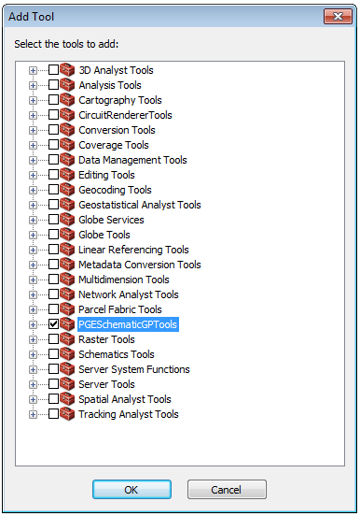To install the PGE Schematic Geoprocessing Tools just run the PGESchematicGPTools_Setup.exe on the target machine and take all default settings. Once installation is complete you will be able to access the PGE Schematic Geoprocessing Tools from ArcToolbox within ArcMap.

To add the PGE Schematic Geoprocessing Tools into ArcToolbox you will need to create a new toolbox. Perform the following steps in ArcMap:

* Make certain ArcToolbox is open
* Right click on the root ArcToolbox node and select “Add Toolbox”.
* Navigate to a folder where you would like to create the toolbox and give it an appropriate name such as “PGE Schematic Tools”.
* Click OK to create the toolbox. The new toolbox will appear in ArcToolbox
* Right click on the new toolbox in ArcToolbox and select “Add” and then “Tool”
* In the ‘Add Tool” dialog window check the checkbox next to “PGE Schematic Geoprocessing Tools”
* Click on OK
* The “PGE Schematic Geoprocessing Tools” will appear to your toolbox.

# Uninstalling

It is important to uninstall the PGE Schematic Geoprocessing Tools before uninstalling ArcGIS Desktop. Use the normal “Programs and Features” dialog accessible from your “Control Panel” to uninstall the tools.

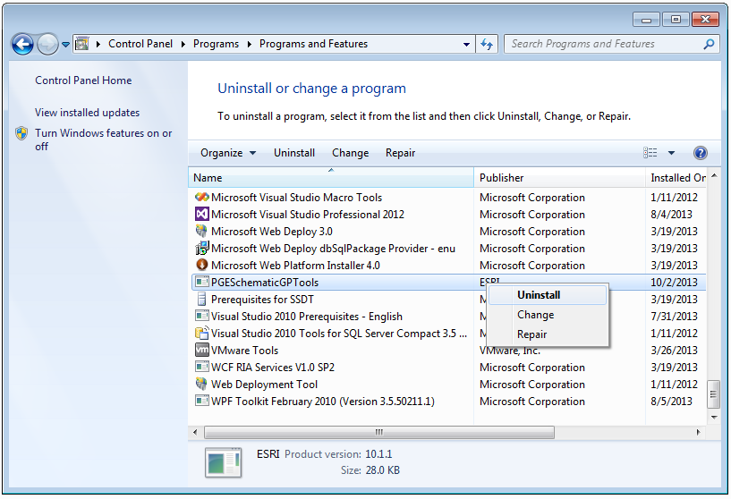

# Geoprocessor Settings

You may want to consider setting a couple of geoprocessing properties before running the tool. Geoprocessing properties can be set using the Geoprocessing Options dialog which can be viewed from the Geoprocessing menu.

In particular you may want to set the following options:

* Overwrite the outputs of geoprocessing operations
* Add results of geoprocessing operations to the display

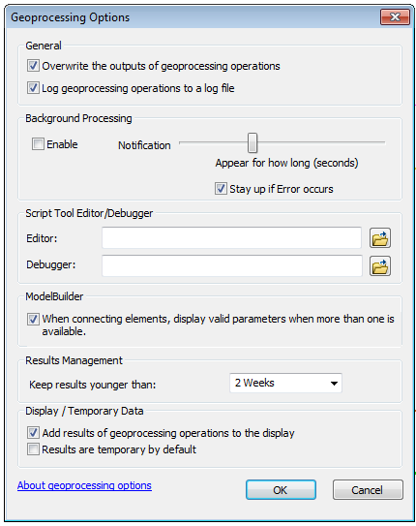

# The Circuit Renderer Tool

The Circuit Renderer Tool uses lookup tables to generate a unique values renderer for displaying circuit lines in ArcMap.

#### Running the Circuit Renderer Tool

To run the Circuit Renderer Tool, first load the PGE Schematic GP Tools into ArcMap, as described earlier. Double click on “Circuit Renderer Tool” to open the tool. Set the input parameters as needed (see below) and click OK to begin processing.

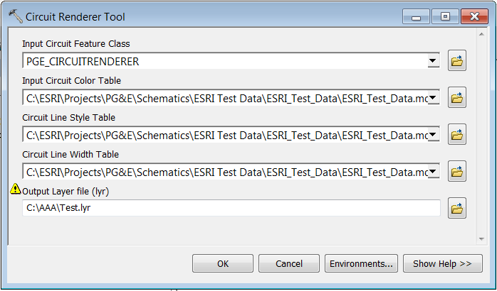

Results can be viewed by opening the Results window from the Geoprocessing menu. Messages will describe the current status of the process and will list any error that may be encountered.

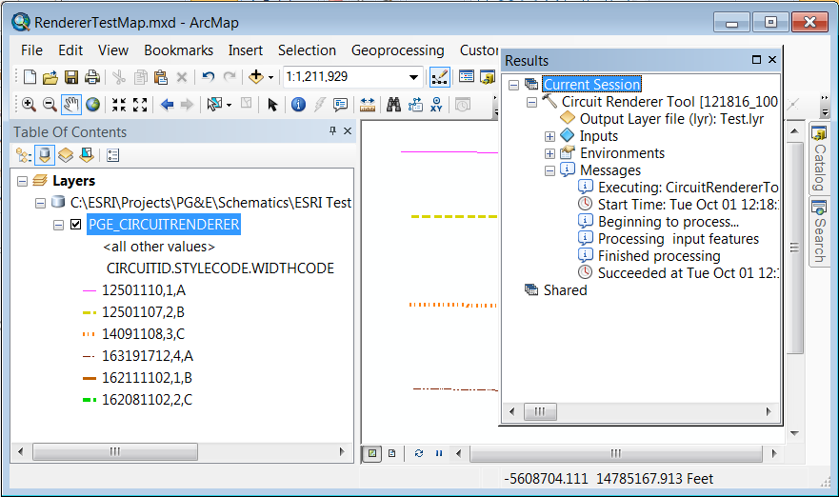

Circuit Renderer Tool Input Parameters

**Input Circuit Feature Class**

This is a line feature class or feature layer which must contain one feature for each CircuitID to be included in the renderer. Although this must be a feature class, it does not have to contain polylines. The shapes can be null because the tool is only used to create a renderer, not display rendered features.

Because the tool performs a table join during processing between the feature class and the color table the feature class must be stored in the same database as the color table described below.

The Input Circuit Feature Class must contain the attributes listed in the following table.

|  |  |  |
| --- | --- | --- |
| Name | Type | Description |
| CIRCUITID | text | Contains Circuit IDs |
| STYLECODE | short | Contains values that correspond to the STYLECODES stored in the line style table. |
| WIDTHCODE | text | Contains values that correspond to the WIDTHCODES stored in the line width table. |

**Input Circuit Color Table**

This is a standalone table which contains RGB values needed to create line colors. There is one entry in this table for each CircuitID. The RGB color components are stored three attribute fields: one for Red, another for Green and a third for Blue.

The Input circuit Color Table must contain the attributes listed in the following table.

|  |  |  |
| --- | --- | --- |
| Name | Type | Description |
| CIRCUITID | text | Contains Circuit IDs |
| REDVALUE | short | A value for the red component in the range between 0 and 255. |
| GREENVALUE | short | A value for the green component in the range between 0 and 255. |
| BLUEVALUE | short | A value for the blue component in the range between 0 and 255. |

**Input Line Style Table**

This is a standalone table which contains line style values. There is one entry in this table for each type of supported line style.

The Input Line Style Table must contain the attributes listed in the following table.

|  |  |  |
| --- | --- | --- |
| Name | Type | Description |
| STYLECODE | short | Contains a valid line style code value from 1 to 4  1 = solid  2 = dashed  3 = dotted  4 = dash dot dot pattern |
| STYLEVALUE | short | This field contains integer values which correspond to an Esri enumeration for line styles. The values are as follows:  0 = solid  1 = dashed  2 = dotted  3 = dash dot dot pattern |

**Input Line Width Table**

This is a standalone table which contains line width values. There is one entry in this table for each type of supported line width.

The Input Line Style Table must contain the attributes listed in the following table.

|  |  |  |
| --- | --- | --- |
| Name | Type | Description |
| WIDTHCODE | text | Contains the line width codes such as ‘A’, ‘B’, ‘C’ |
| WIDTHVALUE | double | The line width expressed as a double |

**Output Layer File**

This is a file system path to the location where the output layer file is to be created. If the layer file already exists and you have “Overwrite the outputs of geoprocessing operations” enabled this file will be replaced. After the tool has finished running this file will contain the the renderer generated by the tool. You can use this layer file to import a renderer into a feature layer in ArcMap as long as the feature layer has a CircuitID field, a StyleCode field and a WidthCode field.

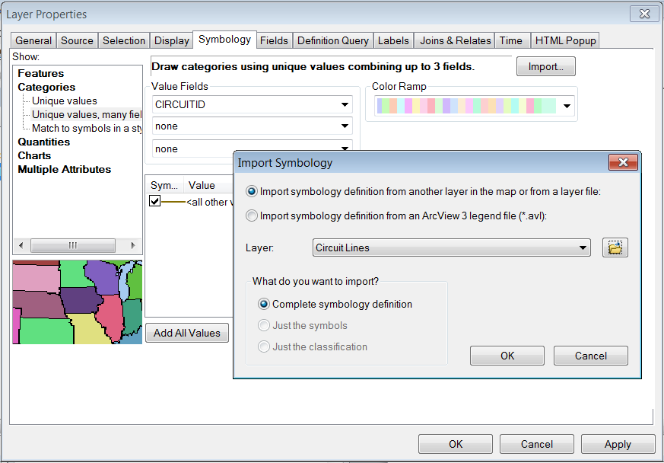

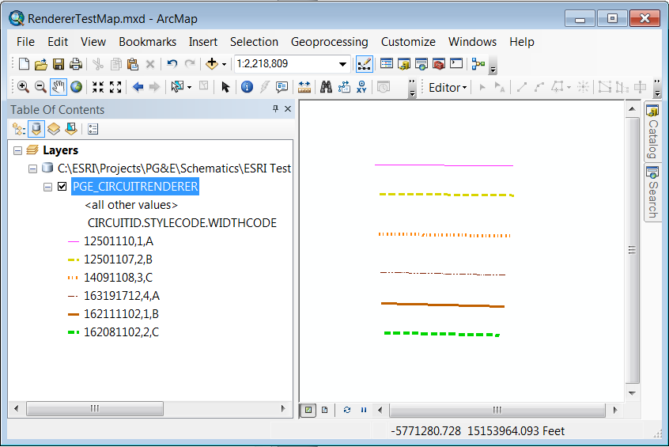

#### Using the Circuit Renderer Tool in a Model

The Circuit Renderer Tool can be used in a geoprocessing model. The main advantage of using it in a model is that the lookup tables can be provided in the model so that the user does not have to provide them at runtime.

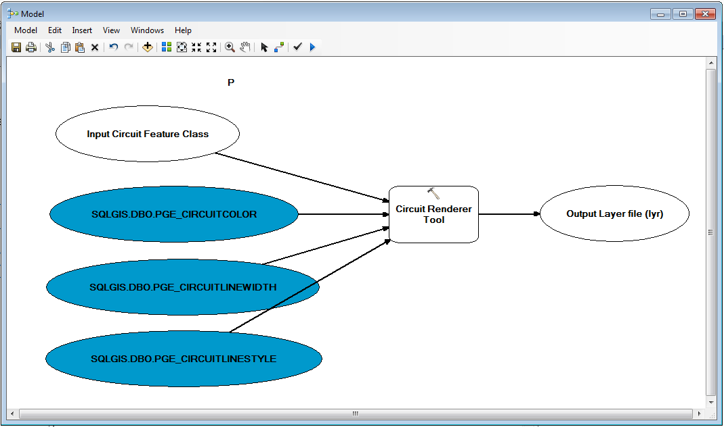

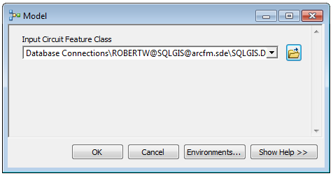

# The Related Features Buffer Tool

The Related Features Buffer Tool retries a set of identifiers from a standalone table. Each identifier is used to select features from a point feature class and from a line feature class. The selected features are buffered and subsequently added to an output feature as polygon parts. The result is a multi-part polygon feature for each identifier.

#### Running the Related Feature Buffer Tool

To run Related Features Buffer Tool, first load the PGE Schematic GP Tools into ArcMap, as described earlier. Double click on the “Related Features Buffer Tool” to open the tool. Set the input parameters as needed (see below) and click OK to begin processing.

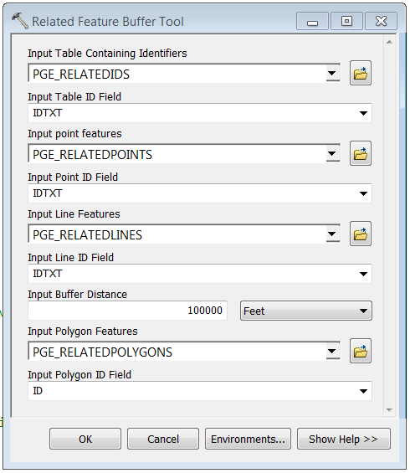

Results can be viewed by opening the Results window from the Geoprocessing menu. Messages will describe the current status of the process and will list any error that may be encountered.

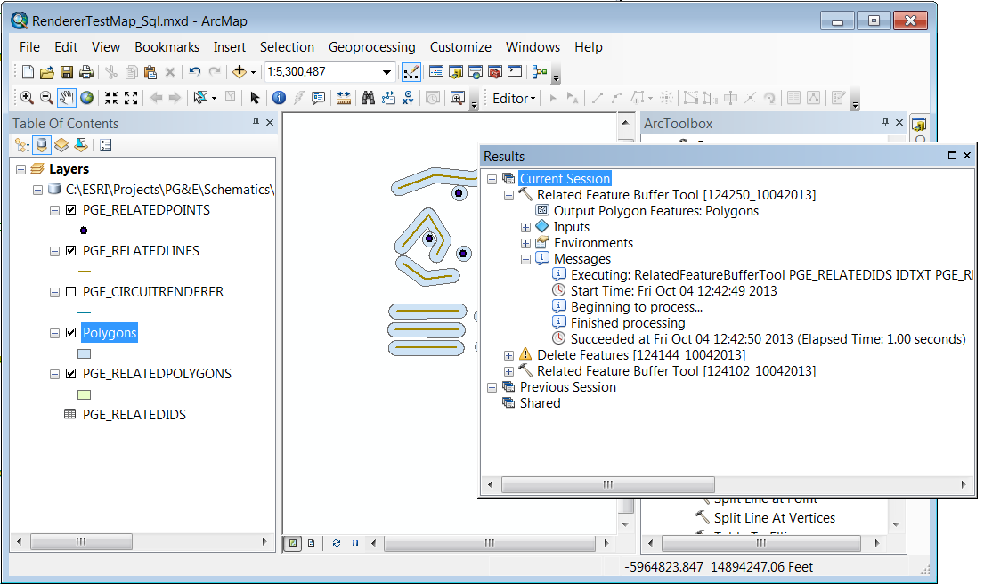

Related Features Buffer Tool Input Parameters

**Input Table Containing Identifiers**

This is a stand-alone table which contains the identifiers that tool will use for selecting points and lines.

**Input Table Field**

This is a text field contained in the ID Table which stores identifiers. All of the identifiers in the ID Table will be processed by the Related Features Buffer Tool.

**Input Point Features**

This is a point feature class or feature layer which contains the points with identifiers that match the identifiers stored in the ID Table.

**Input Point ID Field**

This is a text field contained in the Point Layer which stores identifiers.

**Input Line Features**

This is a line feature class or feature layer which contains the lines with identifiers that match the identifiers stored in the ID Table.

**Input Line ID Field**

This is a text field contained in the Line Layer which stores identifiers.

**Input Buffer Distance**

This is the distance used by the Related Features Buffer Tool to buffer each point and line features that it processes. The distance must be positive and greater than zero. Use the pick list to change the units of measure for the distance, if needed.

**Input Polygon Features**

This is a polygon feature class or feature layer. Polygons generated by the Related Features Buffer Tool will be appended into this data set.

**Input Polygon ID Field**

This is a text field contained in the Polygon Layer which stores identifiers.

In addition to the input parameters the Related Features Buffer Tool outputs the modified polygon feature layer.

How the Related Features Buffer Tool Works

When the Related Features Buffer Tool begins to process it first opens the ID Table and reads all of the identifiers contained in the ID Field. Each identifier is used to select points and lines from the point and line feature layers. The selected features are buffered using the distance parameter and the resulting buffers are combined into a multi-part polygon which is appended into the polygon feature class. Once an identifier from the ID Table has been finished the process continues with the next identifier.

